Fulfillment SOP: pick, then ship
A paid order becomes a pick. You scan that pick on the handheld. Validating the pick creates the delivery. The label, the box, and the final Validate are done on the computer.
Picking is the mobile barcode app. Everything after that is the desktop delivery order (WH/OUT).
The red box in each picture is the control that step is talking about.

1. What you are looking at
Confirming a sales order does not print a label. It creates a pick named WH/PICK/…. That pick moves the units from stock onto the packing table (WH/Stock → WH/Output). The customer shipment, WH/OUT/…, is created when that pick is validated.
If the customer asked to ship what is in stock now and the rest when Victron stock arrives, there are two picks. Read the note on the pick:
- In stock now: “Shipment of immediate stock. The rest will be fulfilled on WH/PICK/….”
- Waiting on Victron: “Stock to be sent from the Victron order. Purchase P… has been raised to fill this order.”
- Customer chose to wait: one pick. “Customer has elected to wait for extra stock to arrive. Fulfil this order with stock from PO P….”
Pick the in-stock one now. Leave the Victron pick until that purchase order is received.

2. Pick on the scanner
Open the Barcode app on the handheld. You do not start this from the sales order.
1. Tap Operations.
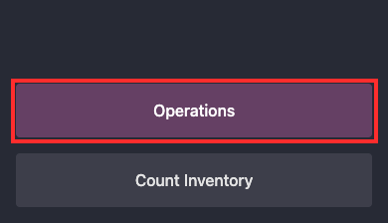
Barcode home. Operations is the purple button. Ignore Install and the push-notification warning.
2. Tap Pick. The number is how many picks are Ready.
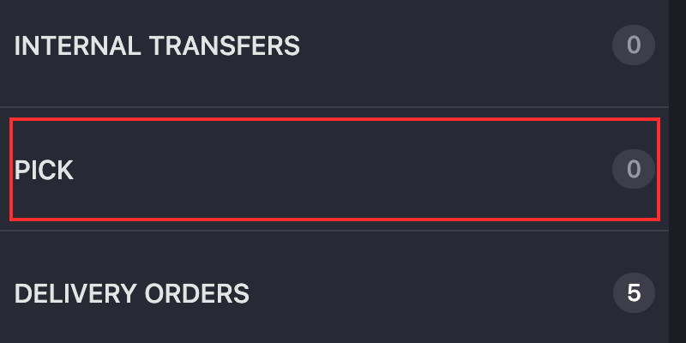
Pick is the row to open. Delivery Orders is not where you scan. A count of 0 means nothing is Ready.
3. Open the pick for this customer. You can also scan the pick’s barcode to open it.
4. The top bar says Scan a product. On the handheld, press the button on the side of the scanner. The barcode icon in the corner is the on-screen camera, if the side button is not what you are using.
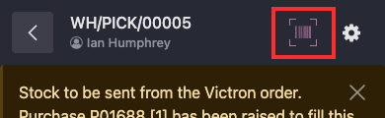
The barcode icon on a pick (WH/PICK/00005). The side button on the scanner is the hardware trigger. This icon is the on-screen one.
5. Scan the serial number on the unit. The serial is enough. The product is already known from it. If a GTIN and a serial are printed one above the other, cover the one you are not scanning.
6. The matching line highlights and asks for the serial if you scanned the product code first. Scan the serial second in that case.
7. A wrong scan: tap the minus on that line, then scan the correct serial.
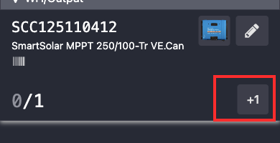
A scanner line. This one is still 0 of 1, so the only button showing is +1. Once a unit is scanned, the minus appears in that same corner and takes the scan off. Do not tap +1 to add a unit you did not scan. The line on a pick looks the same.
8. The line turns green when that product’s quantity is filled. The prompt goes back to “Scan a product” for the next unit.
9. When every line is green, Validate turns purple. Tap it. That means the units are picked. It does not ship them and it does not print a label.
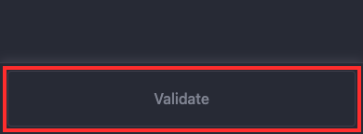
Validate on the pick. It stays grey until every line is green, then it turns purple. This pick is still waiting on Victron, so it is grey and there is nothing to scan.
Do not tap Add Product. If the scanner says the product is not reserved for this order, cancel that warning. Leave the unit in stock.
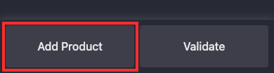
Add Product is on the scanner. Do not use it. It puts a product on the order the customer did not buy.
Do not validate a WH/OUT from the scanner. Scanning is only for the pick.

3. Find the delivery on the computer
After the pick is validated, Odoo creates the delivery. You are still on that pick. Next Transfer opens the delivery.
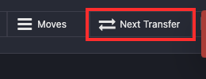
Next Transfer on the finished pick (WH/PICK/00004). This is the first way onto the delivery.
The other way is the deliveries list:
1. Open Inventory → Operations → Transfers → Deliveries.
2. If the screen is cards instead of a list, click the list icon (the one that looks like lines). It sits with the other view icons at the top right. On a narrow window those icons collapse into a small menu in that same spot.
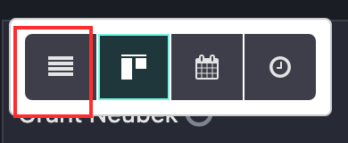
The list icon. The highlighted card icon next to it is the kanban view Deliveries opens in.
3. Open the new WH/OUT for the same sales order. A shipment that has been picked shows From WH/Output and status Ready. Older one-step deliveries show From WH/Stock. The Source Document is the sales order number.
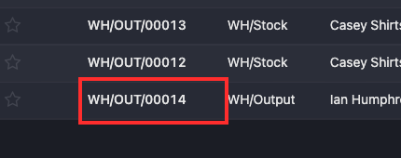
WH/OUT/00014, From WH/Output, customer Ian Humphrey, sales order S00008, status Ready. Click the reference.

4. On the delivery, in the order you click
The product lines should already show the serials you scanned. Do these in this order. Split, when you need it, comes before the label. Validate is last.
1. In the Shippo section, set Shippo Box to the carton this box actually is. Leave insurance at $0 unless this shipment should be insured.
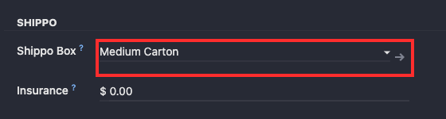
Shippo Box on WH/OUT/00014. This shipment is Medium Carton. Insurance stays at $0 unless this box should be insured.
2. If the order needs a second box, split now, before you buy a label. Click the header Split. Not the gear.
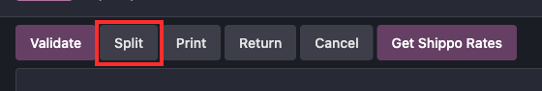
Header Split. This is the one that keeps serial numbers that were already picked. Do this before Get Shippo Rates.
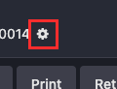
The gear, next to the delivery number. The Split inside this menu is a different command. Do not use that one.
3. For each product, type the quantity that goes in the next box in Split off. What you leave at 0.00 stays on this delivery. Serials already scanned stay on the units you leave here.
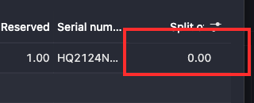
Split off is the 0.00 column. Type the quantity for the next box. Leave 0.00 on anything that stays in this box.
4. Click Split at the bottom of that window. Odoo creates the other delivery immediately. Buy the label and Validate this box first, then open the new delivery and do the same.
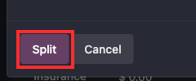
Split confirms the window. Cancel closes it and changes nothing.
The Split command in the gear menu keeps the quantity and drops the serials. Do not use it. Each delivery can send its own tracking email. That is two shipments of one order.
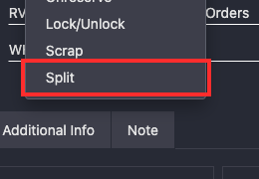
Split at the bottom of the gear menu. This is the one that drops serials.
5. Click Get Shippo Rates. The window shows the box, the weight, and the size. Change the box here if you picked the wrong one.
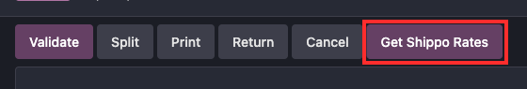
Get Shippo Rates. It does not buy anything.
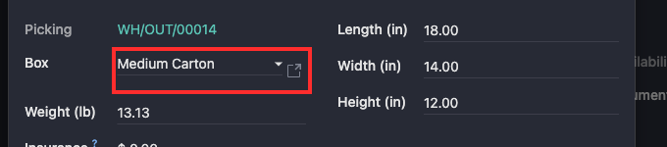
Inside that window, Box is the dropdown. Weight and the three size fields are filled from the carton you picked.
6. Click Get Rates. That lists prices. It does not charge the account.
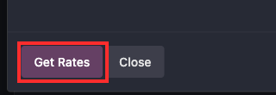
Get Rates. Close leaves without buying.
7. Click the service the customer paid for. Odoo may pre-select a cheaper service, such as Ground Saver. Change it to the one on the order, often UPS Ground. Then click Buy Label. Buying the label is the click that creates the charge.
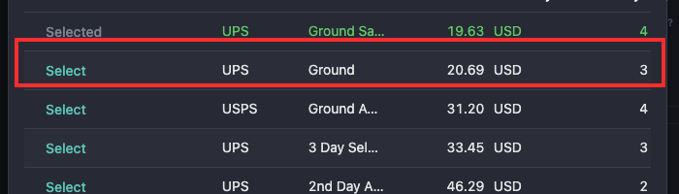
UPS Ground at $20.69. Ground Saver above it was already selected. Click Select on the service the customer paid for.
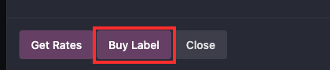
Buy Label charges the account. This picture was taken with the button in front of us. It was not clicked.
8. A new browser tab opens with the label, formatted 4×6 for the Zebra. Print that tab. If it never opens, or you need the file again, click Shipping Label. Print in the header is the delivery paperwork, not that label.
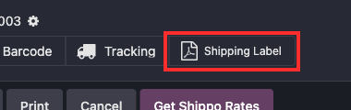
Shipping Label is the file you print. It only appears after a label has been bought. This one is WH/OUT/00003.
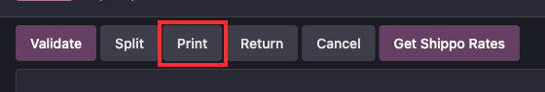
Print, in the header, is not the shipping label. Leave it unless you want the delivery documents.
9. Open Additional Info and read Tracking Reference. It has to be the number you are about to stick on the carton. Tracking opens the carrier’s page. That same link is what the customer gets. Shippo should not also email the customer.
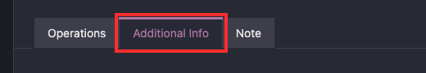
Additional Info is the middle tab, between Operations and Note.
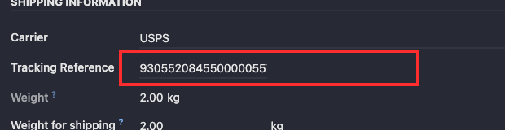
Tracking Reference. Check this before you validate. The number here has to match the carton.
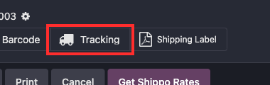
Tracking sits next to Shipping Label. It opens the carrier’s page.
10. Put the label on that box. Then click Validate. Validate means it has left. That is what sends the customer the tracking email from Odoo.
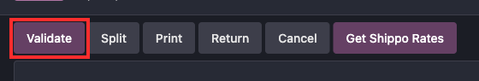
Validate on the delivery. This is the last click.
The Barcode button on the delivery opens the scanner for that shipment. Do not scan or validate the delivery from there. Scanning is only for the pick.
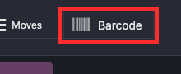
Barcode on the delivery. Leave it.

5. Order of the buttons
1. Scanner: scan every serial on the pick, then Validate the pick.
2. Computer: Next Transfer on that pick, or open the WH/OUT from Deliveries.
3. Choose the box. Split first if you need a second box.
4. Get Shippo Rates → Get Rates → the paid service → Buy Label.
5. Print from Shipping Label (or the tab that just opened). Check Additional Info.
6. Label on the box, then Validate the delivery.
Validating the delivery before the label is on the box marks it shipped with nothing to stick on the carton. If that happens, or if a scan, a split, or a label goes wrong, use the fixes below. Do not correct any of these with an inventory adjustment. An adjustment changes the quantity without a receipt or a delivery, and that throws off cost.

6. Mistakes and how to fix them

Two barcodes got scanned as one
Victron labels sit on top of each other: the product code and the serial. The scanner takes whichever one the beam hits, and it will accept a part number as if it were a serial.
Cover the code you are not scanning. If the line already shows the wrong value, tap the minus on that line. The bad scan comes off. Scan the serial on the unit in your hand. The minus sits where +1 is in the picture above, once the count is above zero.

The unit is not on this pick
The scanner says the product is not reserved for this order. It is in the system, and it is not this customer’s.
Press Cancel on that warning. Leave the unit in stock. Do not tap Add Product.

The same serial is already in the system
A serial can belong to one unit. Scanning it again is rejected. That number is already on another record, often because the receipt stored the wrong code.
Do not ship the box under a serial that is not printed on it. Look the product up in Inventory → Physical Inventory and read the serial Odoo has in stock. Pick that unit, or stop and correct the receipt before this pick is validated. Do not type a new serial onto the pick to force a match.

The scanner asks for a source location, or for a signature
A pick does not need a location barcode, and it does not need a signature.
Back out of the pick. Don’t scan a random barcode, and don’t sign a name, to get past the prompt. Leave the pick unvalidated and have that prompt turned off. Then open the pick again.

There is nothing to pick
Operations shows Pick 0, the pick says it is already done, or the screen is only the note and a grey Validate, with no product lines. A Victron remainder looks like that until its purchase order is received. The banner names the purchase order.
Leave it. Receive that purchase order first. Don’t validate an empty pick, and don’t scan units onto a pick that is already done.

Validate was pressed on the pick too early
The lines were not all the right units, but Validate was purple and it got tapped. The units are now on the packing table and a WH/OUT exists. Nothing has shipped, and no customer email has gone out.
Do not buy a label, and do not Validate the delivery. Click Cancel on that delivery first, so the serials are no longer reserved on it. The units are still on the packing table. Open the finished pick and click Return. Validate the return. That moves them from the packing table back to stock.
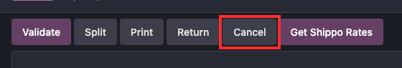
Cancel on the delivery. Use this before a label is bought, when the pick was validated too early. It does not delete the sales order.
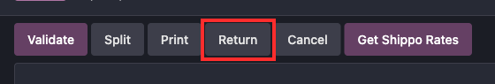
Return on the delivery, or on the finished pick. It creates the reverse transfer. The quantity does not move until that new transfer is validated.
Don’t start another pick until the sales order has an open delivery again. If cancelling the delivery left the order with no shipment, leave the units in stock and flag the sales order. Don’t put them back with an inventory adjustment.

The delivery was validated before the label was on the box
Validate on the computer means it has shipped. The customer email goes out. The label file is still on the delivery.
If the label was already bought, open it with Shipping Label, print it, and put it on the box before the carrier scans the package. If no label was bought, click Return on that delivery. Returning a delivery creates a receipt back into stock. Validate the receipt. The shipment is undone and the units are back. Then pick and ship again. The customer may already have the shipped email. Don’t adjust the quantity by hand to “put it back.”

The wrong service, the wrong box, or a label you are not going to use
Get Rates does not charge. Buy Label does. The charge is for the label, not for the carrier pickup. A label the carrier never scans can be voided.
On the delivery, open the gear and click Refund Shippo Label. The tracking number comes off the delivery, and the chatter says not to use that label. Tear it up. Shippo confirms the refund afterward. It is not instant. The gear item will refuse a second refund while one is already queued, pending, or successful.
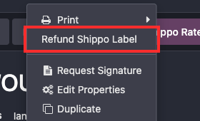
Refund Shippo Label is in the gear menu, and only on a delivery that still has a label. Do not confirm it unless that label is unused. This picture stops at the menu.
If the carrier has already scanned the package, the refund is refused. The shipment stands. Don’t buy another label for the same box.
A missing or invalid phone number makes Shippo refuse the purchase. Put a phone on the warehouse contact and on the delivery contact, click Get Rates again, and buy once.

Buy Label was clicked twice, or the print tab never opened
The label opens in a new browser tab, 4×6. If that tab didn’t appear, or the Zebra is down, click Shipping Label on the delivery. That opens the same file. Print to PDF and use another 4×6 printer if you have to.
Don’t click Buy Label again to “get the tab back.” A second click purchases another label and replaces the tracking number on the delivery. The first label is still a real charge. The gear refund voids only the label currently stored on the delivery. The earlier tracking number is in the chatter, on the “Shippo label purchased” note. Don’t put that label on a box. Give that tracking number to whoever runs the Shippo account so it can be voided there.

Split was done with the gear menu
The Split command in the gear menu keeps the quantity and drops the serials that were already picked. The header Split button is the one that keeps them.
If the gear split already ran, open both deliveries before you buy a label or validate. The serials that survived are on one of them. The other has quantities and blank serials. Scan those serials onto that delivery, the same way you pick, and confirm each line shows the serial printed on the unit. Then buy the label.

The header Split refuses, or the quantities are wrong
The header Split only runs on a delivery that is still open. It tells you which of these it is:
- This delivery already has a tracking number. Refund that label first. Splitting is allowed once the tracking number is gone.
- This delivery can no longer be split. It is done or cancelled. A shipped box is a new shipment, not a split of this one.
- Leave at least one unit on this delivery. Split off is the quantity for the next box. Leave the rest at zero so it stays here.
- You can split at most… The number is larger than what this delivery still has.
If the split amounts are wrong and neither delivery has a label and neither is validated, don’t ship them that way. Split again so each delivery matches the units actually in that box. Splitting never merges two deliveries back into one, and cancelling the new delivery does not put those units back on the first. Leave both open until each one shows the serials that are physically in its box.

The customer got two tracking emails, or an email with no tracking
Two boxes are two deliveries, so two emails is the normal result. Each email should be the tracking number on that box.
An email with a blank tracking number means Validate happened with no label on the delivery, or the label was refunded and the tracking field was cleared. Don’t send the template again until Additional Info shows the tracking number that is on the carton. The tracking button on the delivery should open the carrier’s page in one click. That is the same link the customer gets. Shippo should not send its own email.

Still to write: returns
The returns walkthrough is not in this SOP yet. The rule, so it is not done as an inventory adjustment: on a receipt or a delivery, click Return. Returning a receipt creates an outgoing transfer back to the vendor. Returning a delivery creates a receipt back into stock. Open that new transfer and Validate it. Until it is validated, the quantity has not moved. A manual quantity change is what throws off cost, because it is not tied to a receipt or a delivery.

